**EXPERIMENT 7:** *Performing CRUD Operations on Apache HBase*

**Name: Adwait Purao**

**UID : 2021300101**

**Division: COMPS B**

1. Create Table Badminton
   1. **Query** : *create ‘badminton’,‘badmintonname’*

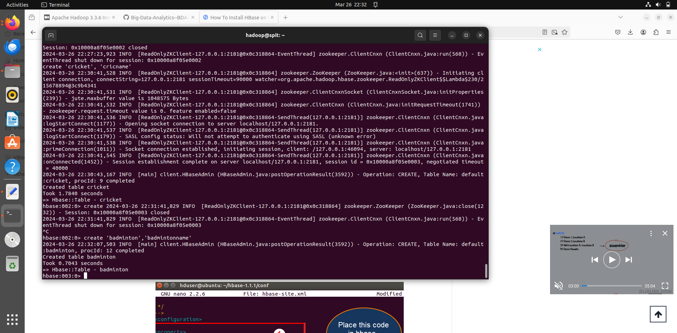

1. Scan Table Badminton
   1. **Query** : *scan ‘badminton’*

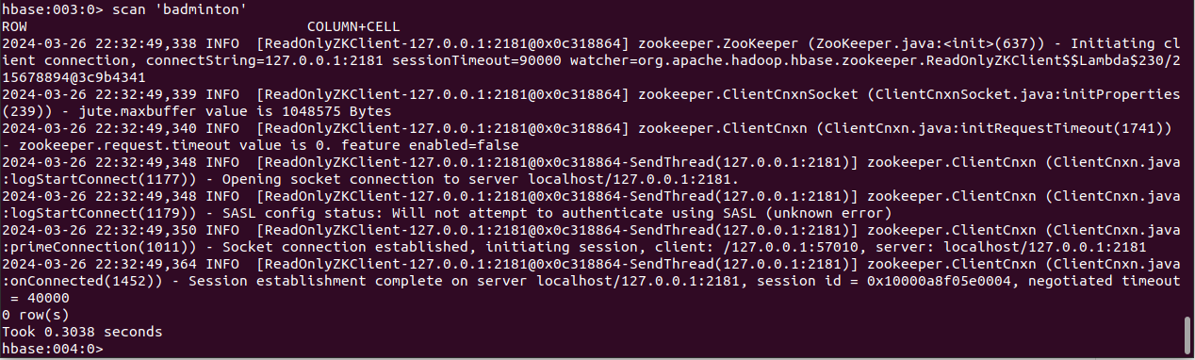

1. Put Data into Table Badminton
   1. **Query** : *put ‘badminton’,‘r1’,‘badmintonname’,‘adwait’*



1. Deleteall data in a row in Table Badminton
   1. **Query** : *deleteall ‘badminton’,‘r1’*

